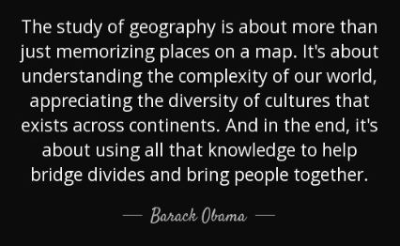

Geography at Henry Hinde Junior School

During their time at Henry Hinde Junior, each child will learn about geography through a relevant, engaging and purposeful curriculum.
The summer term is focused on geographical learning. The following global regions are explored by the children:

Year 3 – UK (including rivers, mountains and pollution)
Year 4 – Europe (a comparison between the UK and another)
Year 5 – South America (rainforests)
Year 6 – The World (natural disasters)

At the start of each project, the children are introduced to the over-arching question they will ultimately be answering, as well as enjoying a Stunning Start Day. These involve various exciting activities to capture the children’s interest and imagination.

Pupils become geographers; practising the skills they need to become successful learners. These include, but are not limited to: map reading, including grid references; comparing different localities considering their physical features; locating continents and countries; exploring topical geographical issues. As a result, when our pupils move on to secondary education, they are well-equipped to continue their learning.

