Category: | Operations
Authorised By: | Board of Trustees
Author: | Business Operations and Estates manager
Version | V.2
Status: | Under Review:
 | Approved: |  | ✓
 | Adopted: |  | ✓
Issue Date: | June 2021
Next Review Date: | June 2022
Statutory Policy: | Yes | Yes
 | No
First Aid Policy
(N.B – this policy provides a template to be adapted at academy level.)

Contents

Section | Page
1. Scope | 3
2. Policy Statement | 3
3. Roles and responsibilities | 3
4. Procedures | 4
5. First aid equipment | 5
6. Record keeping and reporting | 5
7. Training | 7
8. Monitoring | 7
Appendices  1. List of appointed persons or trained first aiders  2. Accident report form  3. First aid training log | 8  9  10

1 – Scope

The aims of Transforming Lives Educational Trust (TLET) through the implementation of this policy are:

- to ensure the health and safety of all staff, pupils and visitors at all TLET sites.
- to ensure staff and AIM Boards are aware of their responsibilities with regards to health and safety at their academy site/s.
- to ensure staff and AIM Boards are aware of their responsibilities with regards to health and safety when engaged in activities taking place offsite, such as, but not limited to, school trips and sporting events.

2 – Policy Statement

This policy is based on advice from the Department for Education on first aid in schools and health and safety in schools, and the following legislation:

- The Health and Safety (First Aid) regulations 1981, which state that employers must provide adequate and appropriate equipment and facilities to enable first aid to be administered to employees, and qualified first aid personnel
- The Management of Health and Safety at Work Regulations 1992, which require employers to make an assessment of the risk to the health and safety of their employees
- The Management of Health and Safety at Work Regulations 1999, which require employers to carry out risk assessments, make arrangements to implement necessary and arrange for appropriate information and training
- The Reporting of Injuries, Diseases and Dangerous Occurrences Regulations (RIDDOR) 2013, which state that some accidents must be reported to the Health and Safety Executive (HSE), and set out the timeframe for this and how long records of such accidents must be kept
- Social Security (Claims and Payments) Regulations 1979, which set out rules on the retention of accident records
- The Education (Independent School Standards) Regulations 2014, which require that suitable space is provided to cater for the medical and therapy needs of pupils

3 - ROLES AND RESPONSBIBILITIES

3.1 Appointed person(s) and first aiders

Henry Hinde Junior School appointed Miss Jennie Nurse & Mrs Rachael Kite they are responsible for:

- Taking charge when someone is injured or becomes ill
- Ensuring there is an adequate supply of medical materials in first aid kits, and replenishing the contents of these kits
- Ensuring that an ambulance or other professional medical help is summoned when appropriate
First aiders are trained and qualified to carry out the role (see section 7) and are responsible for:
- Acting as first responders to any incidents; they will assess the situation where there is an injured or ill person, and provide immediate and appropriate treatment
- Sending pupils home to recover, where necessary
- Filling in an accident report on the same day, or as soon as is reasonably practicable, after an incident (see the template in appendix 2)
- Keeping their contact details up to date

Henry Hinde Junior School appointed person and first aiders are listed in appendix 1. Their names will also be displayed prominently around the site.

3.2 The AIM Board

The AIM Board has ultimate responsibility for health and safety matters in the school, but delegates operational matters and day-to-day tasks to the Principal and staff members.

3.3 The Principal

The Principal is responsible for the implementation of this policy, including:
- Ensuring that an appropriate number of trained first aid personnel are present in the school at all times
- Ensuring that first aiders have an appropriate qualification, keep training up to date and remain competent to perform their role
- Ensuring all staff are aware of first aid procedures
- Ensuring appropriate risk assessments are completed and appropriate measures are put in place
- Undertaking, or ensuring that managers undertake, risk assessments, as appropriate, and that appropriate measures are put in place
- Ensuring that adequate space is available for catering to the medical needs of pupils
- Reporting specified incidents to the HSE when necessary (see section 6)

3.4 Staff

Staff are responsible for:
- Ensuring they follow first aid procedures
- Ensuring they know who the first aiders in school are
- Completing accident reports (see appendix 2) for all incidents they attend to where a first aider is not called
- Informing the Principal or their manager of any specific health conditions or first aid needs

4 - Procedures

4.1 On-site procedures

In the event of an accident resulting in injury:
- The closest member of staff present will assess the seriousness of the injury and seek the assistance of a qualified first aider, if appropriate, who will provide the required first aid treatment
- The first aider, if called, will assess the injury and decide if further assistance is needed from a colleague or the emergency services. They will remain on scene until help arrives
- The first aider will also decide whether the injured person should be moved or placed in a recovery position
- If the first aider judges that a pupil is too unwell to remain in school, parents will be contacted and asked to collect their child. Upon their arrival, the first aider will recommend next steps to the parents
- If emergency services are called, the Principal and the Office Manager will contact parents immediately
- The Principal will complete an accident report form on the same day or as soon as is reasonably practical after an incident resulting in an injury

4.2 Off-site procedures

When taking pupils off the school premises, staff will ensure they always have the following:
- A school mobile phone
- A portable first aid kit
- Information about the specific medical needs of pupils
- Parents’ contact details
Risk assessments will be completed by the Class Teacher and checked by the Principal prior to any educational visit that necessitates taking pupils off school premises.

There will always be at least one first aider on school trips and visits.

5 - FIRST AID EQUIPMENT

First aid kits are stored in:

- The medical room
- Classrooms

6 - RECORD KEEPING AND REPORTING

6.1 First aid and accident records
- An accident form will be completed by the first aider/relevant member of staff on the same day or as soon as possible after an incident resulting in an injury
- As much detail as possible should be supplied when reporting an accident, including all of the information included in the accident form at appendix 2
- Records held in the first aid and accident book will be retained by the school for a minimum of 3 years, in accordance with regulation 25 of the Social Security (Claims and Payments) Regulations 1979, and then securely disposed of.

6.2 Reporting to the HSE

The Office Manager will keep a record of any accident which results in a reportable injury, disease, or dangerous occurrence as defined in the RIDDOR 2013 legislation (regulations 4, 5, 6 and 7).

The Principal will report these to the Health and Safety Executive as soon as is reasonably practicable and in any event within 10 days of the incident.
Reportable injuries, diseases or dangerous occurrences include:
- Death
- Specified injuries, which are:
  - Fractures, other than to fingers, thumbs and toes
  - Amputations
  - Any injury likely to lead to permanent loss of sight or reduction in sight
  - Any crush injury to the head or torso causing damage to the brain or internal organs
  - Serious burns (including scalding)
  - Any scalping requiring hospital treatment
  - Any loss of consciousness caused by head injury or asphyxia
  - Any other injury arising from working in an enclosed space which leads to hypothermia or heat-induced illness, or requires resuscitation or admittance to hospital for more than 24 hours
- Injuries where an employee is away from work or unable to perform their normal work duties for more than 7 consecutive days (not including the day of the incident)
- Where an accident leads to someone being taken to hospital
- Near-miss events that do not result in an injury, but could have done. Examples of near-miss events relevant to schools include, but are not limited to:
  - The collapse or failure of load-bearing parts of lifts and lifting equipment
  - The accidental release of a biological agent likely to cause severe human illness
  - The accidental release or escape of any substance that may cause a serious injury or damage to health
  - An electrical short circuit or overload causing a fire or explosion

Information on how to make a RIDDOR report is available here:
How to make a RIDDOR report, HSE
http://www.hse.gov.uk/riddor/report.htm

The Principal will notify Ofsted of any serious accident, illness or injury to, or death of, a pupil while in the school’s care. This will happen as soon as is reasonably practicable, and no later than 14 days after the incident.
The Principal will also notify Warwickshire County Council of any serious accident or injury to, or the death of, a pupil while in the school’s care.

7 - TRAINING

All TLET staff are able to undertake first aid training if they would like to.
All first aiders must have completed a training course, and must hold a valid certificate of competence to show this. The school will keep a register of all trained first aiders, what training they have received and when this is valid until (see appendix 3).

Staff are encouraged to renew their first aid training when it is no longer valid.

8 - MONITORING

This policy will be reviewed by the Business Operations and Estates Manager every two years.

At every review, the policy will be approved by the Principal and or Local Governing Body.

APPENDIX 1 – List of appointed persons or trained first aiders

Staff members name | Role | Contact details
Jennie Nurse | Principal | head@henryhindejunior.co.uk
Rachael Kite | HLTA | rkite@henryhindejunior.co.uk
Adina Bucur | TA | abucur@henryhindejunior.co.uk
Agata Roberts | TA | aroberts@henryhindejunior.co.uk
Amanda Stapleton | Class Teacher / SENDCo | astapleton@henryhindejunior.co.uk
Jessica Evans | Class Teacher | jevans@henryhindejunior.co.uk
Jodi Spence | Class Teacher | jspence@henryhindejunior.co.uk
Lydia Taylor | Class Teacher | ltaylor@henryhindejunior.co.uk
Thomas Daniel | Class Teacher | tdaniels@henryhindejunior.co.uk
Carly Solomon | Family Support Worker | csolomon@henryhindejunior.co.uk
Clare Burnett | TA | cburnett@henryhindejunior.co.uk
Derek Burrell | Caretaker | dburrell@henryhindejunior.co.uk
Fiona Lines | Classteacher | Flines@henryhindejunior.co.uk
Jackie Parker | Classteacher | jparker@henryhindejunior.co.uk
Jacqueline Newton | Classteacher | jnewton@henryhindejunior.co.uk
Melanie Surgeon | TA | msurgeon@henryhindejunior.co.uk
Natalie Corbishley | TA | ncorbishley@henryhindejunior.co.uk

APPENDIX 2 – Accident report form

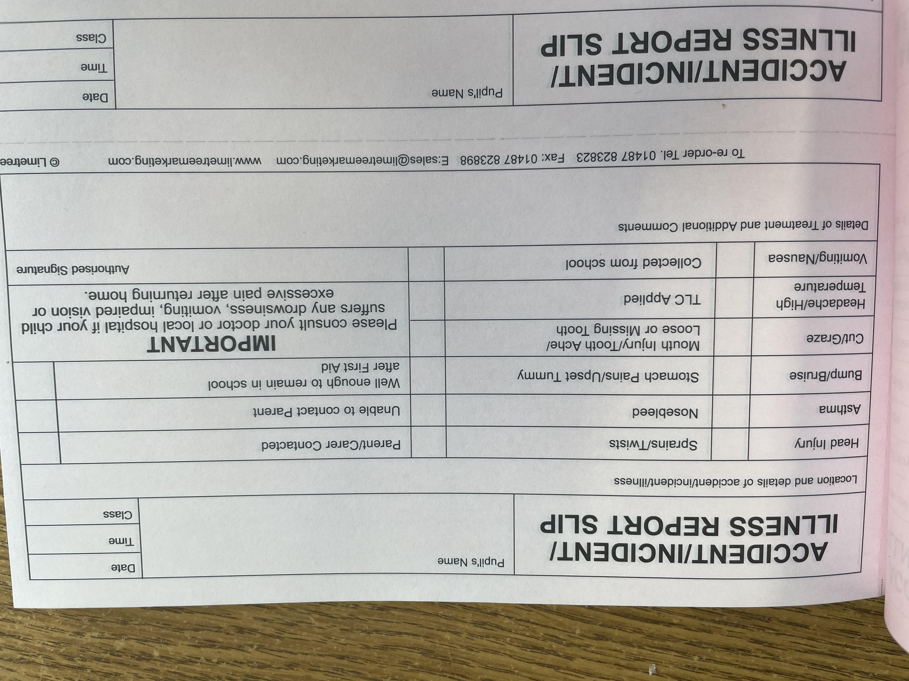

APPENDIX 3 – First Aid Training Log

Name/type of training | Staff who attended (individuals or groups) | Date attended | Date for training to be updated (where applicable)
Emergency Fist Aid at Work including Paediatric Element | All staff above apart from Rachael Kite and Jennie Nurse | Monday 2nd November 2020 | Monday 2nd November 2023
3 Day First Aid at Work | Miss Jennie Nurse | 19th November 2018 | 19th November 2021
QNUK Level 3 First Aid at Work | Mrs R Kite | 4th February 2020 | 4th February 2023

