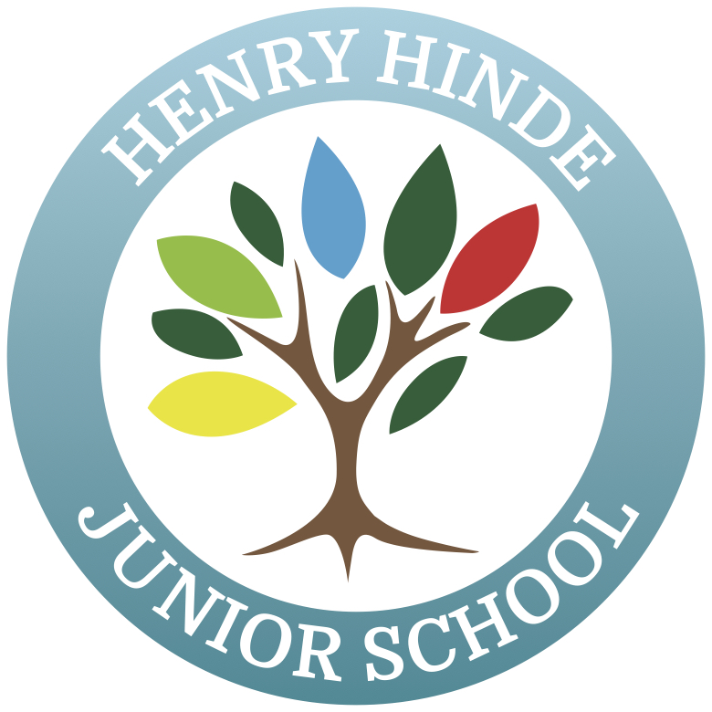

HENRY HINDE JUNIOR SCHOOL

Feedback and Marking Policy
September 2021

Henry Hinde Junior School
Feedback and Marking Policy

Rationale
The work that children produce at Henry Hinde Junior School will be reflective of high quality, purposeful activities and will demonstrate the pride that pupils and staff take in learning. Staff use feedback and marking as a process to check pupils’ understanding as well as inform them about their learning; guiding them towards the next steps and encouraging a sense of ownership in this. Responding to pupils’ work is also utilised as an assessment tool for staff to determine the understanding of each pupil before planning for the next steps in the teaching cycle. This ensures that learning is progressive and appropriately accessible to each pupil.
Feedback can be offered to pupils in a variety of ways and should be utilised to the greatest effect. We recognise the negative impact that increased marking places on staff morale and time; therefore, this policy focuses on the highest impact of feedback without an over-reliance on written comments.
This policy complies with the Teachers’ Standards 2012.
A teacher must:
1. Set high expectations, which inspire, motivate and challenge pupils;
2. Promote good progress and outcomes by pupils;
3. Demonstrate good subject and curriculum knowledge;
4. Plan and teach well-structured lessons;
5. Adapt teaching to respond to the strengths and needs of all pupils;
6. Make accurate and productive use of assessment.
At Henry Hinde Junior School, we believe that each pupil should be taken on a journey of awe and wonder in their learning and will be challenged to achieve their full potential. Together we facilitate inspirational and creative learning opportunities, encouraging children to explore possibilities with enthusiasm and imagination. We promote independence, collaboration and confidence, to equip children for life-long learning.
The expectations we hold of our pupils when presenting work and the feedback we offer to them about their learning is a crucial aspect of this ‘journey’ and underpins the potential progress they can make in their learning.

A Common Code
At Henry Hinde Junior School there is an expectation that all work will be acknowledged by an adult, either using their ‘seen by an adult’ stamp, using the green ticks, or where appropriate, Pink to Think highlighting. There is an expectation that one in every three pieces in books are marked in depth, for the following purposes;
1. Demonstrate we value their work and encourage them to do the same;
2. Give each pupil a clear picture of how far they have come in their learning and to encourage ownership in taking the next steps;
3. Offer specific information on the extent to which they have met the learning objectives and/or the individual targets set for them;
4. Promote self-assessment, whereby they recognise their difficulties and are encouraged to accept guidance from others;
5. Gauge their understanding and identify any misconceptions;
6. Provide a basis for formative and summative assessment which informs future learning activities.
Adults in school will use black pen when writing a comment on children’s work.
Purple pens are used in all year groups by pupils to respond to feedback and this should happen where a teacher has given a Pink to Think. This may need to be modelled to some children in guided sessions and in Year 3, children will receive scaffolded support to respond to Pink To Think.
We use a consistent colour coding system for all forms of feedback to provide a common language for all children, staff and parents. Appendix 1 should be available in the class file for all adults in class and Appendix 2 should be displayed in every classroom for pupils to use. It is introduced to the children in Year 3 and used throughout Key Stage 2. Staff will teach the children the meaning of each colour as appropriate to their age and ability.
Good to be Green Ticks | Pink for Think Highlighting
  I have seen evidence that you have met the learning objective or elements of the success criteria.  Double tick by the learning objective indicates learning objective met in full. | There is area for development in your learning.  You may need to be challenged further, or set a task that consolidates your learning.  A pink highlight indicates the pupil is required to respond with purple pen.

Verbal Feedback
The most impactful form of feedback is the verbal guidance offered face to face by a teacher to a pupil. Staff will offer as much verbal feedback to pupils as possible during the course of an activity and will record this in their book where appropriate with a word or two for brief summary. For example, VF- paragraphing.
Self and Peer-Assessment
Self-assessment encourages pupils to review their work and take responsibility for their learning journey. The learning objective should be referred to throughout the learning and children should be encouraged to take opportunities to evaluate their progress against this at various points. Self/Peer Assessment comments are to be written in a purple pen. There should be valuable opportunities for pupils to assess each other’s work during the course of a learning activity.
As common practice in Years 3 – 6, pupils will utilise self and peer-assessment by writing comments in books. When this occurs peer to peer, pupils will acknowledge ownership by writing their initials next to their comments.
Written feedback
Feedback should always be given against the success criteria and all comments provided by an adult (teacher or LSA) in a pupil’s book must be written black pen using the cursive handwriting, in line with the School Policy, to model expectations to pupils. Comments are expected to be spelled and punctuated correctly and written using Standard English.
Mathematics work is checked using ticks for correct answers and a highlight for errors. It is sometimes difficult to offer next steps comments in Mathematics and it is likely that these will be worked on as a group the following day. Therefore, staff members are not expected to write detailed comments in these books if they are able to demonstrate how outcomes from one lesson are used to inform the planning in the next lesson.
Extended Writing Feedback
Children will be given regular opportunities to write at length. This should be not less than once in 3 weeks. This will often be within English lessons but opportunities should be sought to write longer pieces in other subjects. The expectation is that writing across the curriculum is written to the same high standard as writing in English. Children should be provided with a copy of the success criteria before beginning to write and should provide examples of how they have met the success criteria as they write. This ensures that children are focused on the success criteria throughout and it is a visual check for the teacher that the success criteria are understood and being met.
Writing should be marked in time for the next session to enable the children to reflect on the marking comments and edit and improve their work.
Spelling Feedback
Spelling errors will be marked across the curriculum, but not in every lesson. This is done proportionally, according to the individual child’s age and ability in spelling, using the code in the appendix. Not all spelling errors need to be identified and staff are expected to use their professional judgement to determine which the key ones to focus on are.
In Year 3, teachers will address age appropriate words spelt incorrectly by writing it at the bottom of the page with the code in the appendix. Children should then find this word, spelt incorrectly in the piece and edit it in purple pen.
In Year 4, 5 and until February in Year 6, where appropriate teachers should write SP at the start of the line to indicate that the child has made a spelling error and needs to self-correct it using a dictionary. In some exceptional circumstances teachers underline the word, using a ruler and write SP in the margin for children to edit.
After February in Year 6, spellings will be addressed with the whole class with key spellings on the board for children to then edit in their work. In some exceptional circumstances teachers underline the word, using a ruler, in pink and write SP in the margin for children to edit.
Across the curriculum, subject specific vocabulary spelling errors will be addressed as above.
Homework Feedback
Pupils from Year 3 through to Year 6 are provided with homework each week. It is expected that staff acknowledge this work in good time.
Timescales
In order to ensure the greatest impact on learning, feedback response times must be timely. Verbal feedback is immediate for learning each day but written feedback must be provided by the following lesson. All work should be acknowledged in some form; either through adult marking, peer marking or self-marking.
The Role of Other Adults:
Feedback is the responsibility of the adult teaching the pupils or setting the work. LSAs may be used to mark group work or homework but this must be in line with the feedback policy and must be done outside of a lesson time.
Parents and Carers:
At Henry Hinde Junior School we seek to foster positive working relationships with our parents and carers, which is supported by communicating our policy and practice as clearly as possible. A copy of this policy is available on the school website.
Monitoring:
This policy is monitored by the SLT within the processes of school self-evaluation. The next review is due in July 2022.

Date | May 2021
Principal | Jennie Nurse
Review and update on | July 2022

Appendix 1
Feedback and Marking Codes
Please mark in the following agreed colours; Good to be Green and Pink to Think
Support given | S (in a circle)
Verbal feedback given | VF and a word or two word brief summary
Missing punctuation | Identified in pink (Highlighted)
Spelling error | SP
You have fully met the learning objective, two ticks next to the learning objective.
Evidence that you have met the learning objective or elements of the success criteria.
This answer is incorrect (maths specific) | Highlighted next to answer in pink
Pink to Think | There will be a pink highlight and then black writing from the adult.  This will be written in books if a challenge, edit or consolidation is required.  It is expected that pupils respond to Pink to Think in purple pen, acting accordingly.

Appendix 2
What Does My Feedback Mean?
My adults will mark in black and use the following colours; Good to be Green and Pink to Think. I need to respond in Purple Pen.
I had some support during this lesson | S (in a circle)
I was given some verbal feedback to help improve my learning. | VF and a word or two word brief summary
Missing punctuation | Identified in pink (Highlighted)
I have a spelling error | SP
You have fully met the learning objective, two ticks next to the learning objective.
Evidence that you have met the learning objective or elements of the success criteria.
This answer is incorrect (maths specific) | Highlighted next to answer in pink
Pink to Think | There will be a pink highlight and then black writing from the adult. This will be written in books if a challenge, edit or consolidation is required  You should use your purple pen to respond to this and edit your work.

